Steps for the Course end Project 1:

1. Host machine successfully installed with Git, Java, Jenkins and Docker.

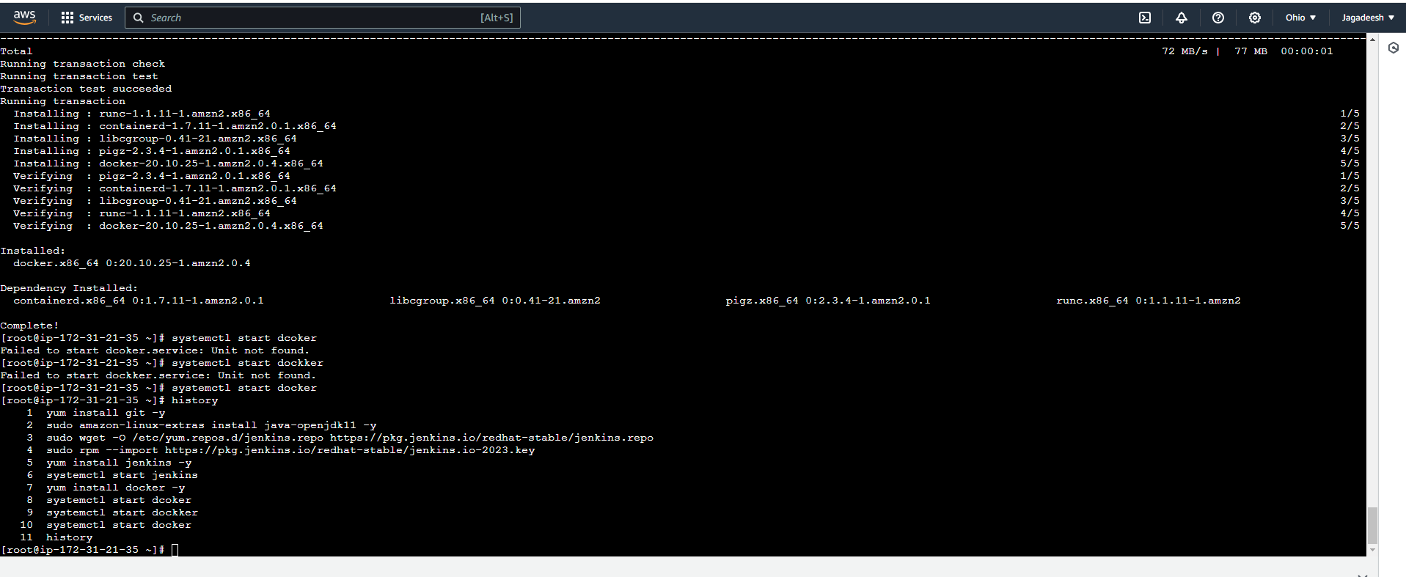

b) Screenshot of code repository in GIThub

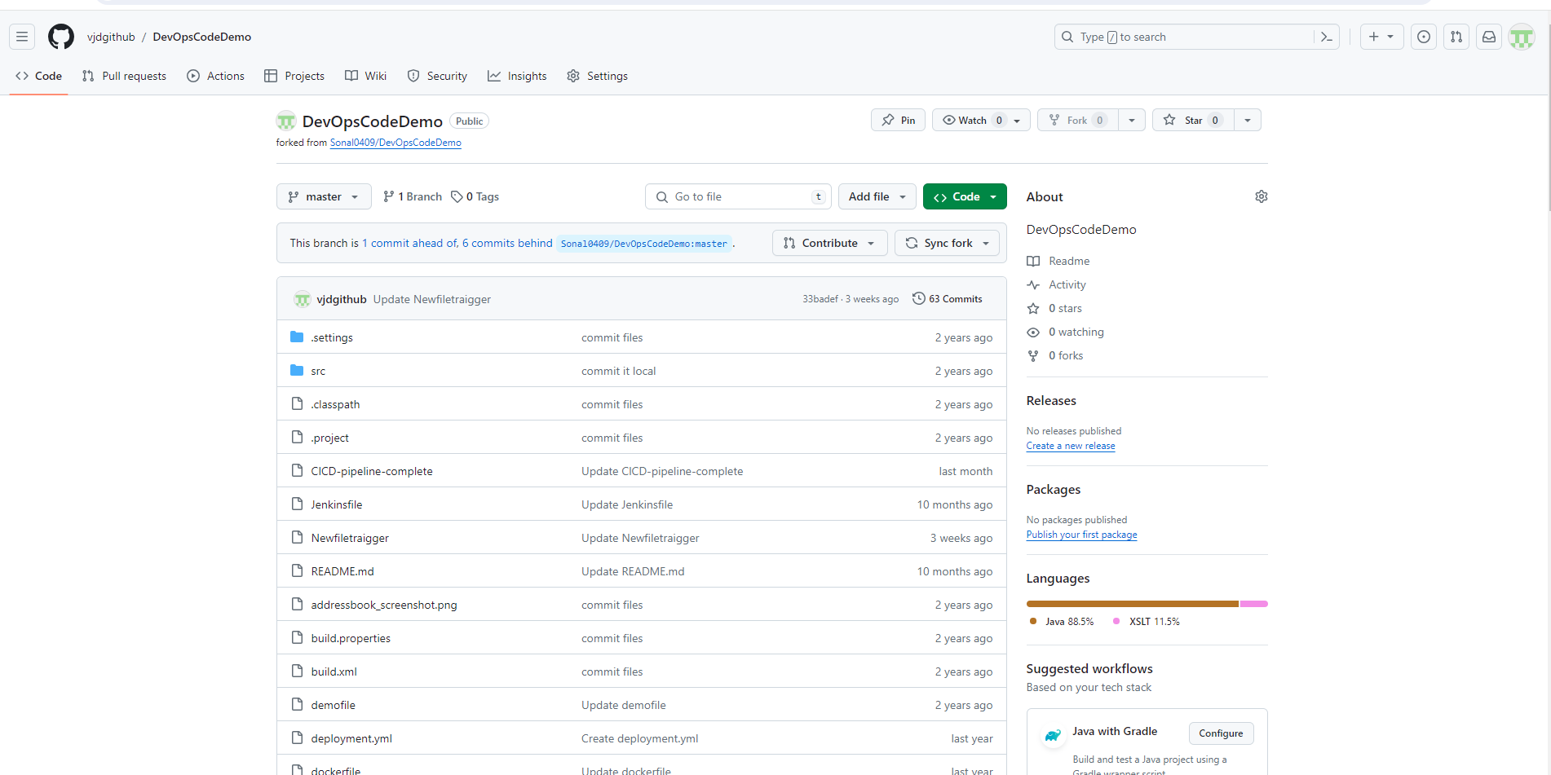

Maven tool configuration:

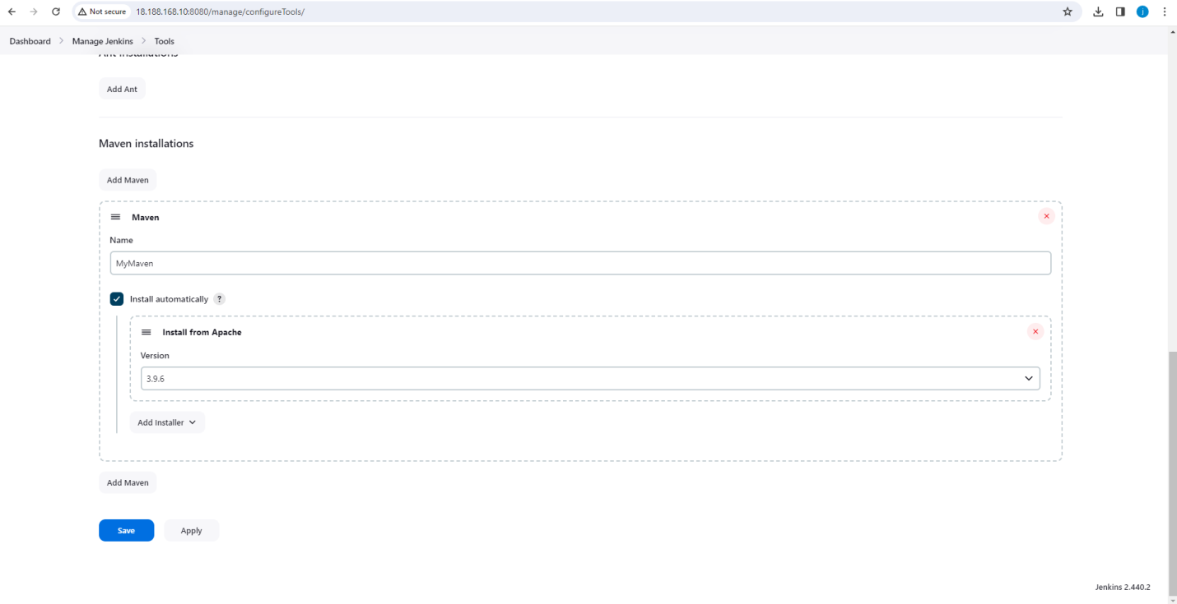

Created a pipeline with maven, java in Jenkins with the following stages:

* Clone the repo
* Compile
* Test
* Package

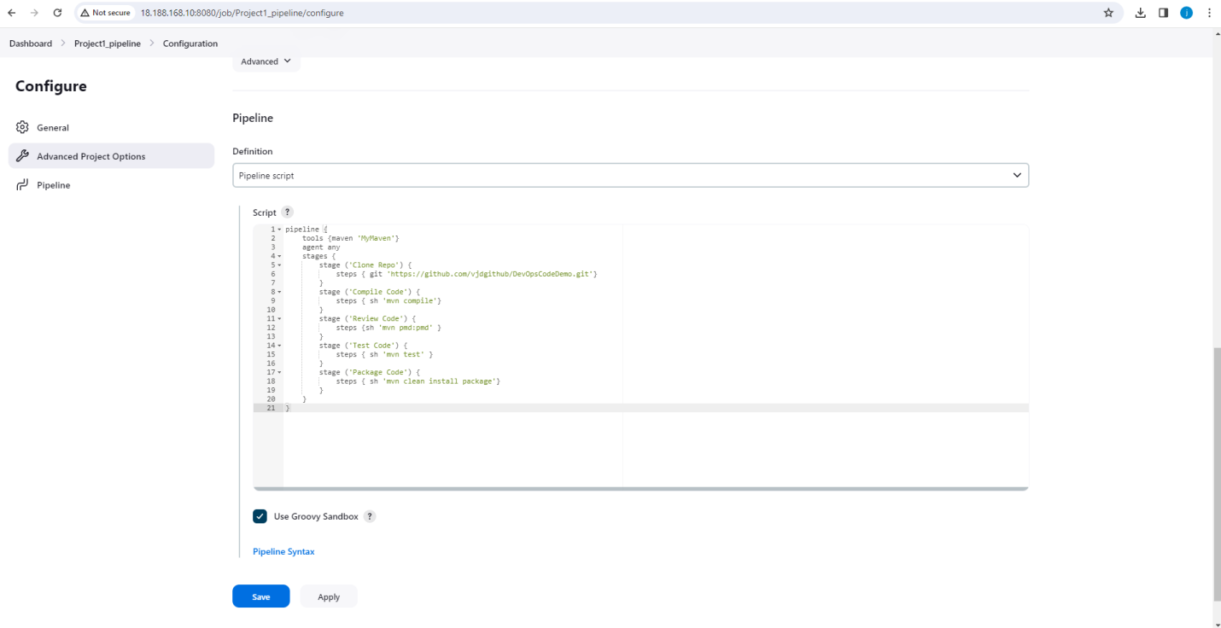

Screenshots of the status view and console output of package job

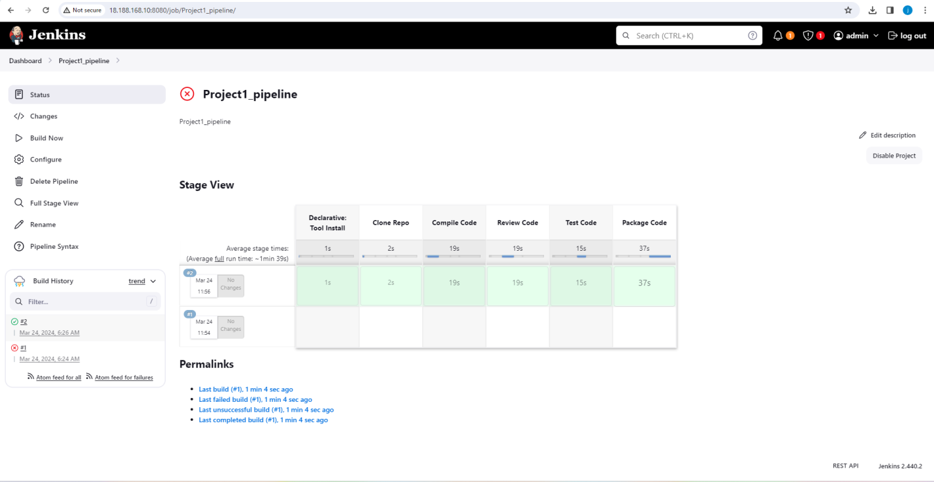

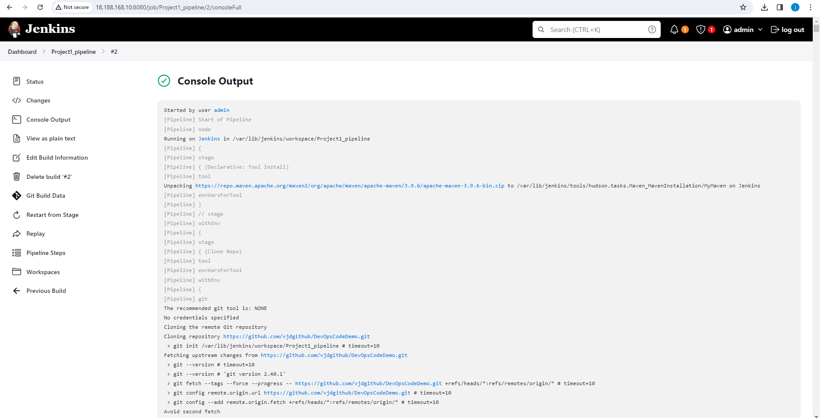

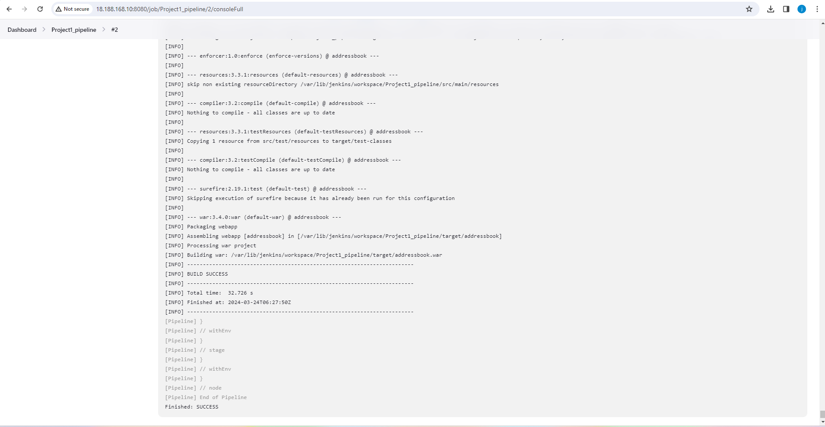

Screenshot of target folder with addressbook.war file

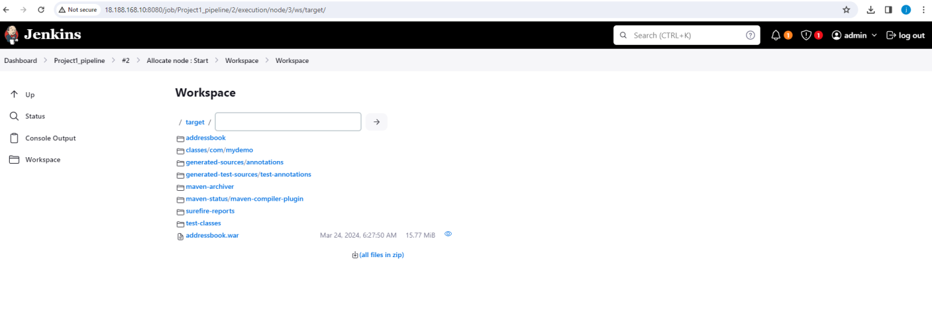

In the same pipeline created a new stage to build the image. The code repository includes your docker file. Used the same dockerfile to build the image. And added one more stage to push image to dockerhub.

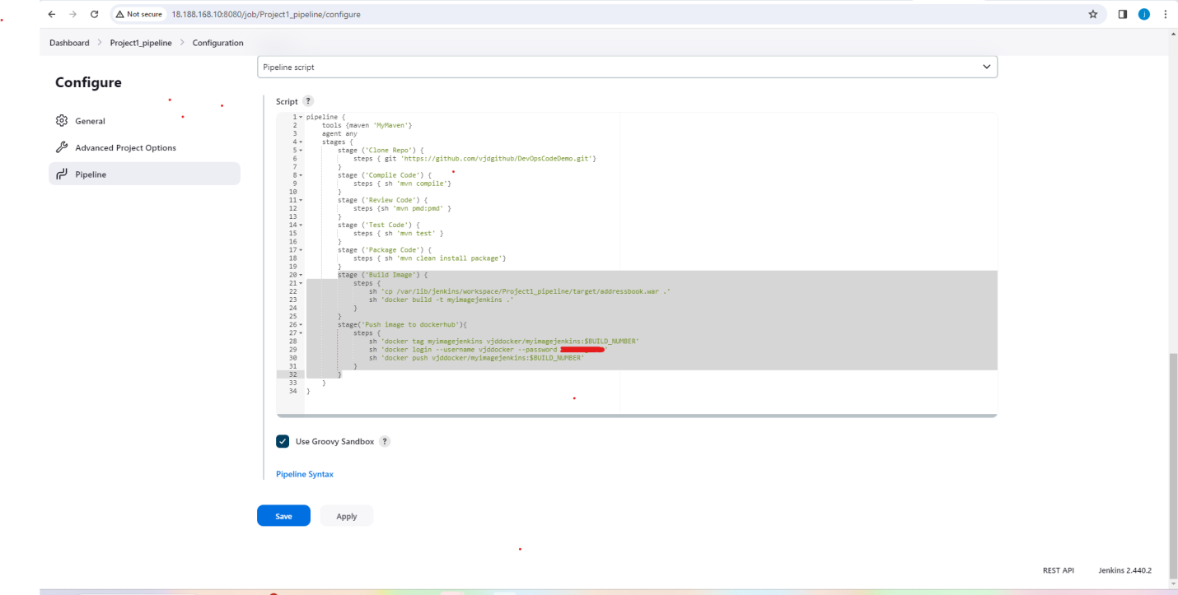

Added a stage to create containers using the above image

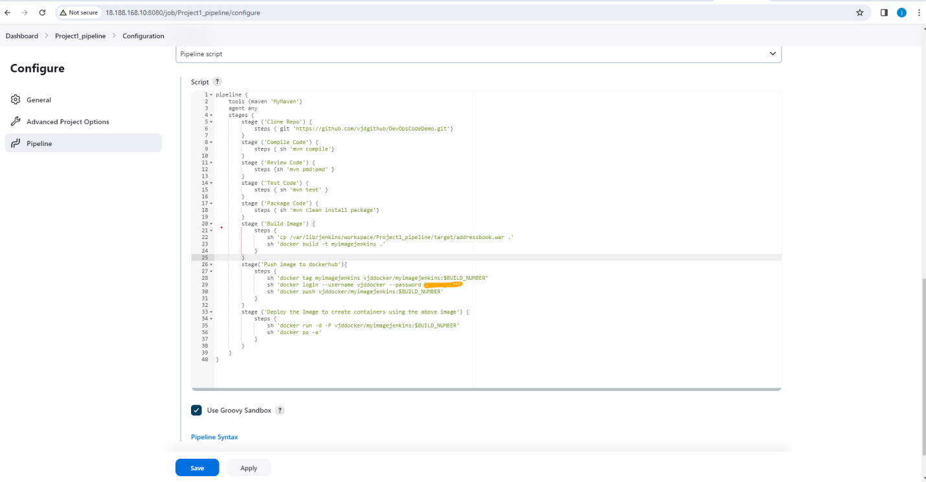

|  |
| --- |
| Saved the job |
|  |
| Go to instance to give jenkins permission to execute docker commands. As of now we are logged in as admin in jenkins and it doesnt have permission to run docker commands. |
|  |
| So go to |
| vim /etc/sudoers |
| I |
| add under root |
| Jenkins ALL=NOPASSWD: ALL |
| :wq!  Or run the below command  chmod 777 /var/run/docker.sock |
|  |
| Go back to jenkins and build now.  Provided screenshots of application deployed on container.        Accessed the application using the url:  <http://18.188.168.10:32768/addressbook/>      [Run the Image using AnsiblePlaybook.yml]   1. Installed the Ansible 2. Added the ansiuser in both the Controller and Host machines 3. Set the PasswordAuthentication to true in /etc/ssh/sshd_config file in both the Controller and Host machines 4. Added the ansiuser for root permissions in /etc/sudoers file. 5. Restarted the sshd as we have done the configuration changes. 6. Switched to ansiuser and generated the ssh keys and copied to host machine 7. Updated the hosts file under /etc/ansible and added the host group webserver with IP 172.31.41.231 8. Created the AnsiblePlaybook.yml as below.      1. Executed the above playbook .      1. Accessed via browser using public IP of host machine and port number and application name as below.   <http://3.14.11.39:32770/addressbook/> |